Supplement B: Results with Hydrologic Benefit Function based on coho juvenile abundance
Claire Kouba
2026-03-10

1 Methodological details of Hydrologic Benefit function formulations (Supplements B-E)
The Hydrologic Benefit (HB) function is intended to estimate the ecological value (in units of fish production) provided to fish by specific flow values (e.g., timing of fall flow increase; magnitude of dry season flow). This is expressed in conceptual mathematical terms as $fish=b+m_{1}*flow_{1}+m_{1}*flow_{2} ⋯$; see methods in Kouba et al. (2025) for more details. It’s important to note that, in this dataset, only 40-60% of variation in fish outcome was explained in models based on flow data, and the HB function does not constitute a prediction of the number of fish outmigrating in a given year.
Specifically, the results below are based on statistical models, using LASSO regression, of reproductive output for two species of salmon (coho and Chinook) in the Scott River stream system. Reproductive output is expressed in units of outmigrating juvenile abundance and normalized juveniles-per-adult spawner; two reproductive units for two species yields the four HB function formulations.
While MARSS models were used as a tool for identifying important functional flows in (Kouba et al. 2025), they are unsuitable for this hydrologic scenario outcome forecasting purpose, due to the nature of autoregression: the forecasting of future fish outcomes requires historical observations of fish outcomes. Therefore, to use MARSS models in estimating the ecological effects of flow changes under different management scenarios, it would be necessary to have historical fish records collected in an alternate reality under the different management scenarios, which is not possible. Similarly, LASSO models which included spawner abundance as a predictor were also not included in this exercise.
Consequently, only LASSO models dependent on hydrologic variables were evaluated as potential tools to forecast the outcomes of flow change on fish reproduction.
For each species, across all statistical methods, the coefficients for any single predictor were consistently negative or positive; e.g., more coho reproduction was consistently associated with earlier fall reconnection.

2 HB coefficients, component contributions, and annual values
Table 1: Coefficients for the Hydrologic Benefit function, an emperical estimate of ecological services provided to coho salmon by specific functional flows. The predicted value is in units of log10(juvenile abundance) produced, modeled using only hydrological factors.
Predictor | Value | Greater Hydrologic Benefit value associated with
Intercept | 3.872 | Intercept Term
f1_FA_Dif_num | 0.162 | Larger fall flow increase (during parents' spawning)
s1_SP_ROC | -0.020 | Slower rate of change, spring recession (as recent hatchlings)
f2_FA_Dif_num | -0.130 | Smaller fall pulse (as juvenile fish)
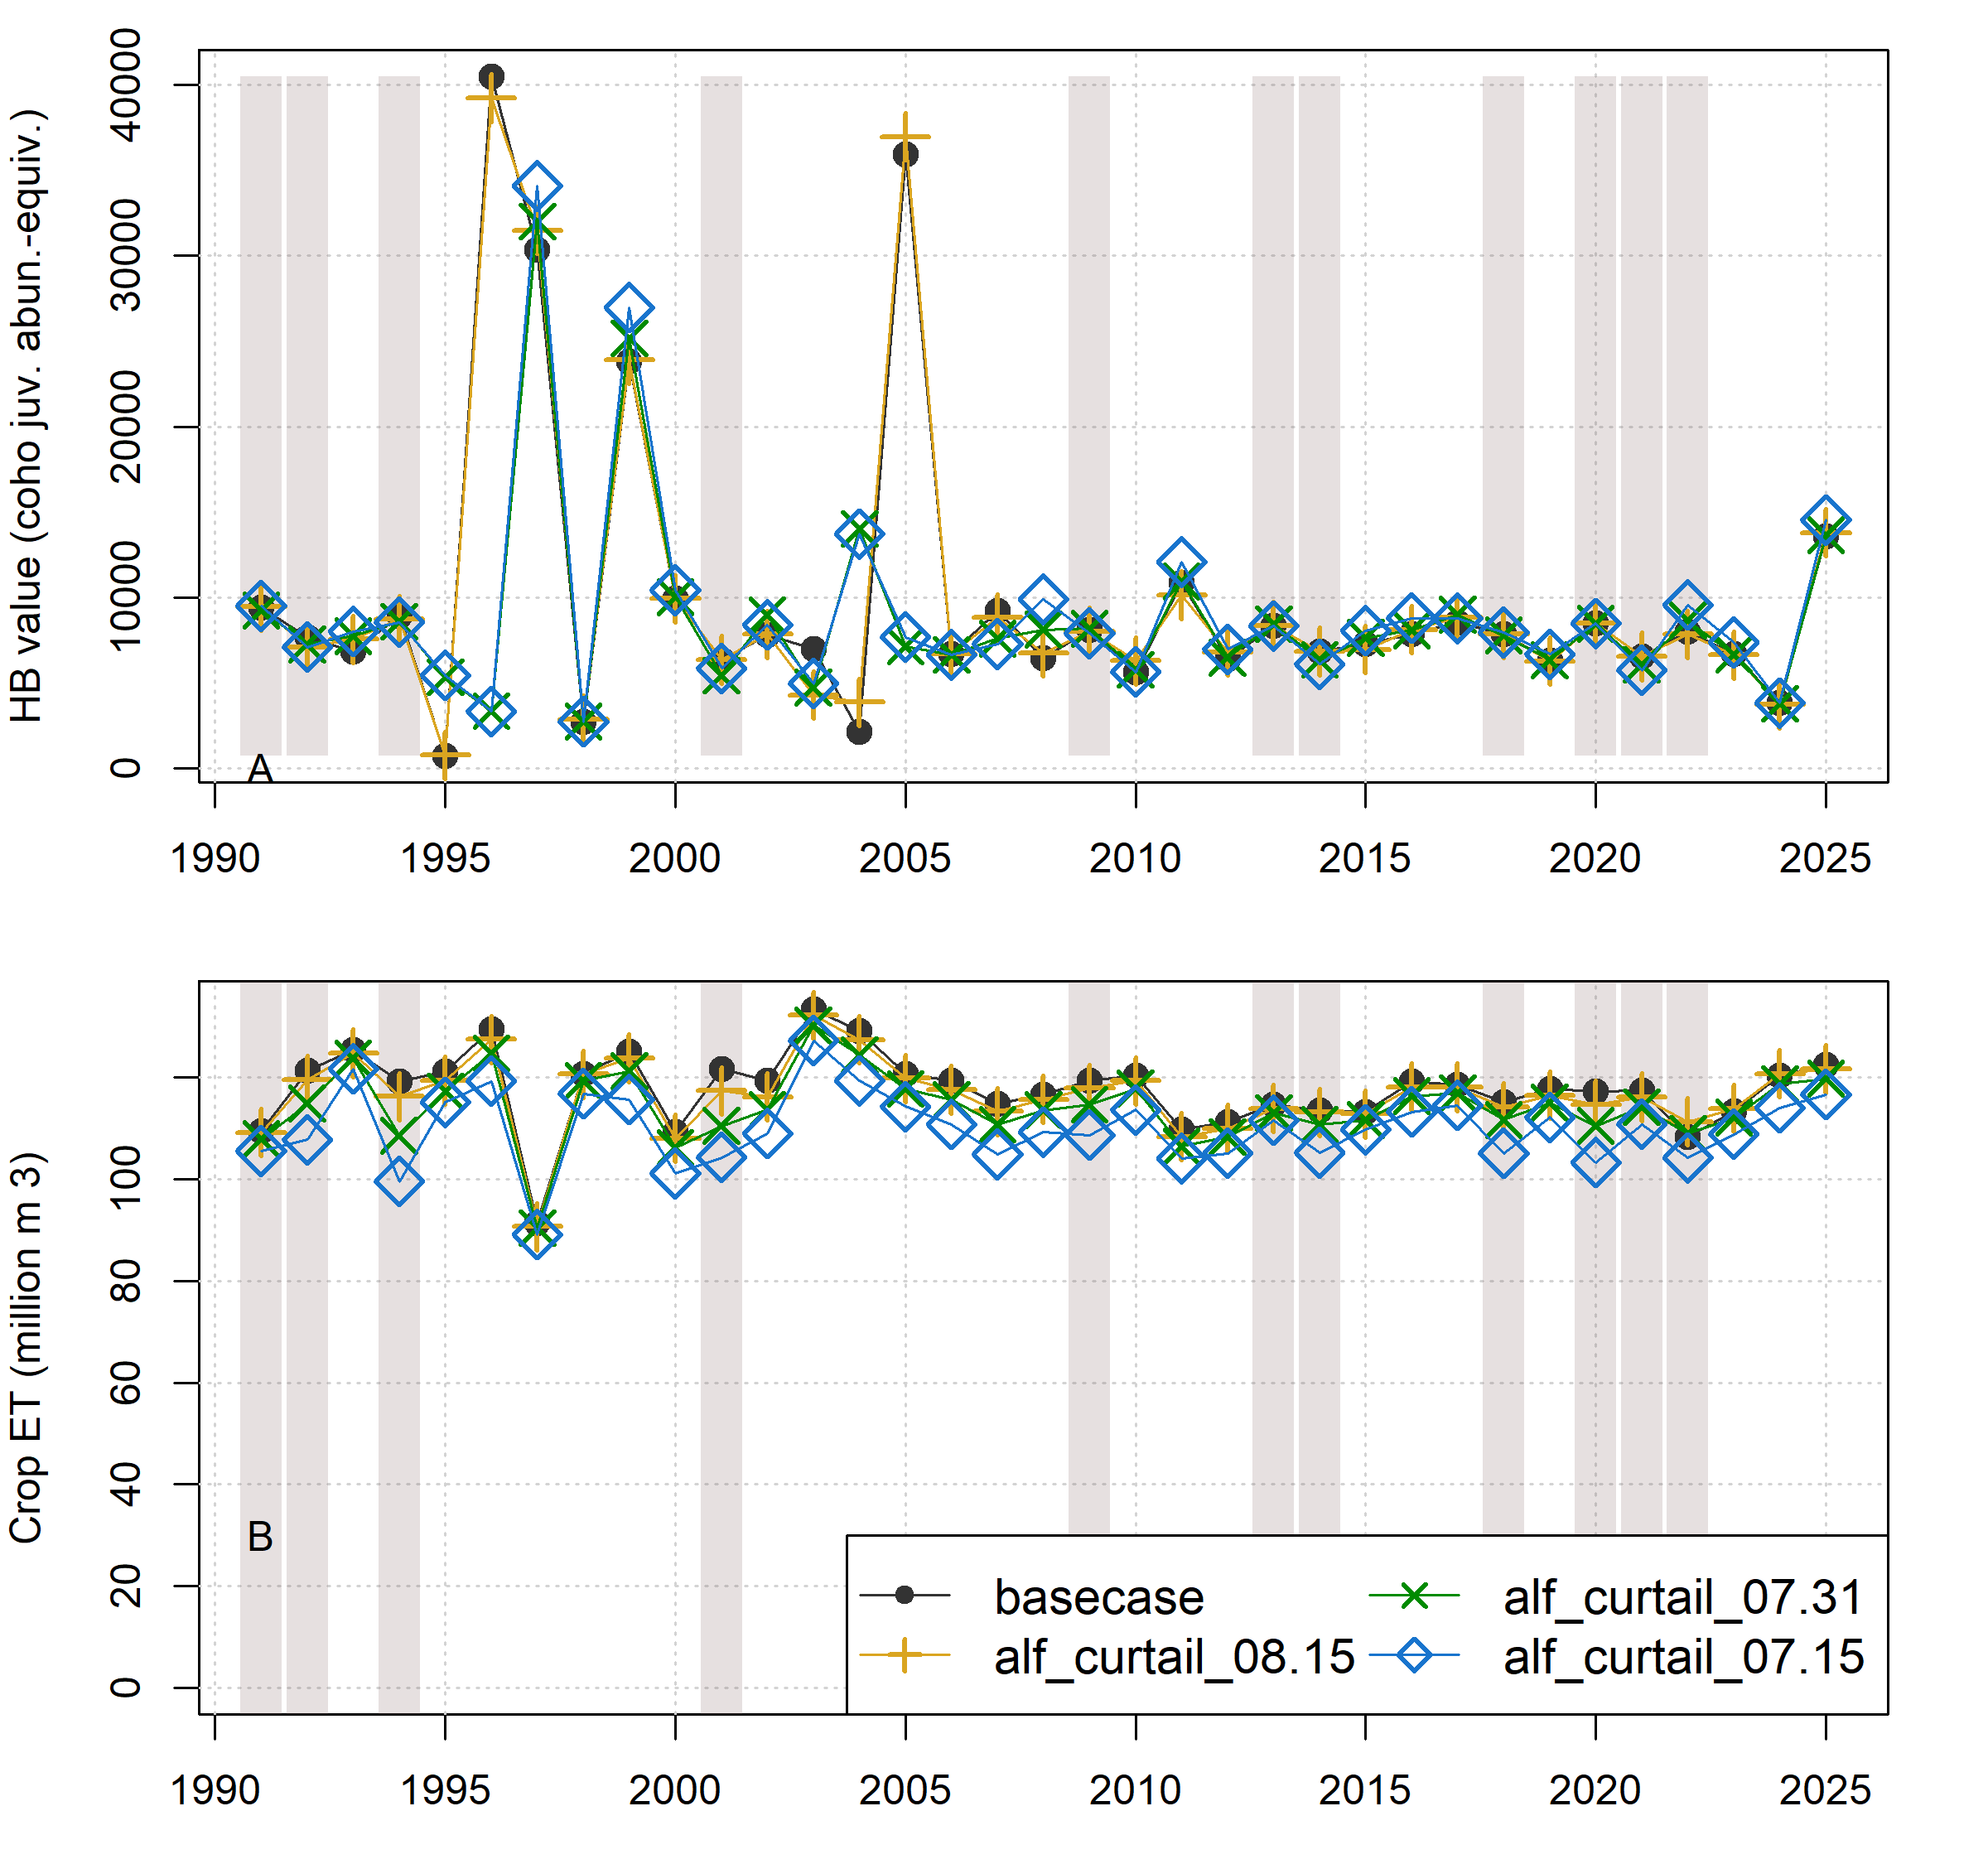
Figure 1: Comparison of annual performance in two objective functions (Hydrologic Benefit and ET, representing environmental and agricultural objectives, respectively) for brood years 1991-2025. The scenarios pictured are basecase (black circles) and a scenario from each of three categories: Enhanced Recharge, Crop Change, and Native Vegetation (Low ET). Dry-type water years (vertical bars) are 1991, ’92, ’94, 2001, ’09, ’13, ’14, ’18, and ’20-’22.
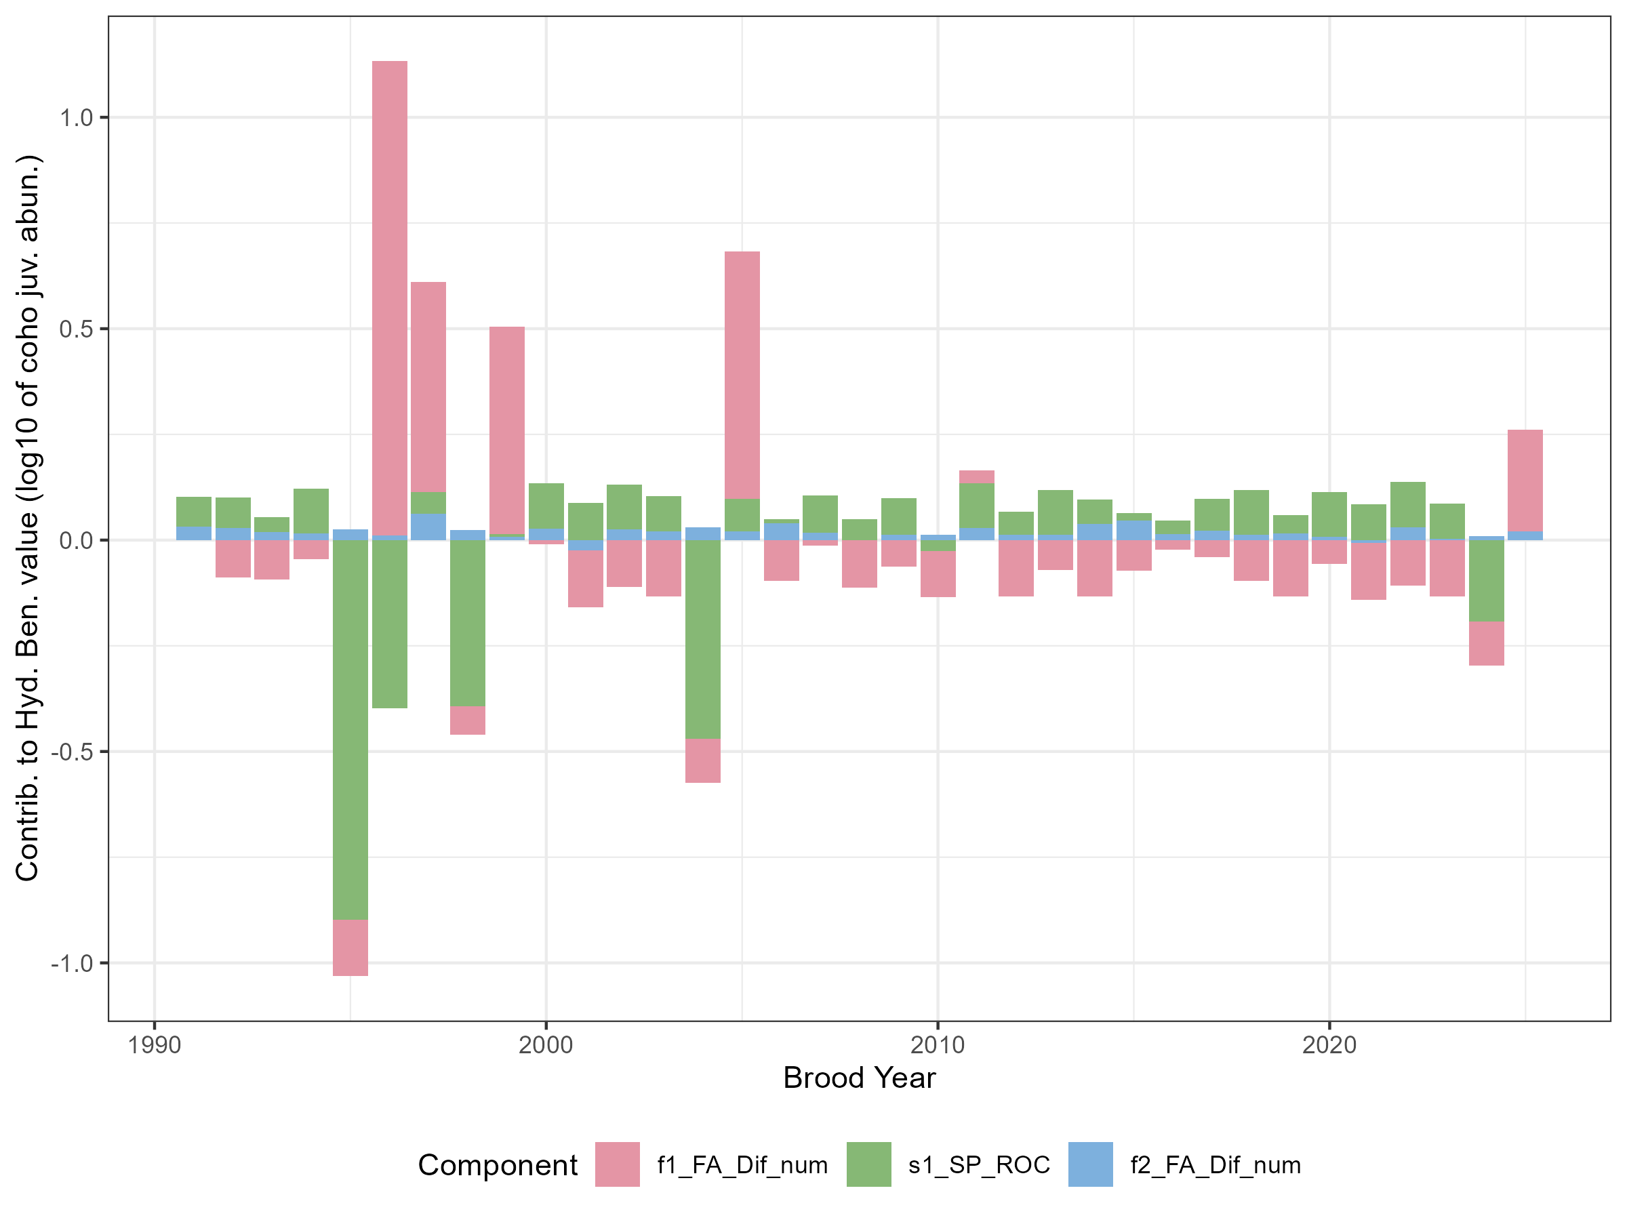
Figure 2: For the basecase scenario, contributions to annual Hydrologic Benefit function values, by functional flow metric (see Table 1 above; intercept values not shown).

3 Trade-offs and efficiency
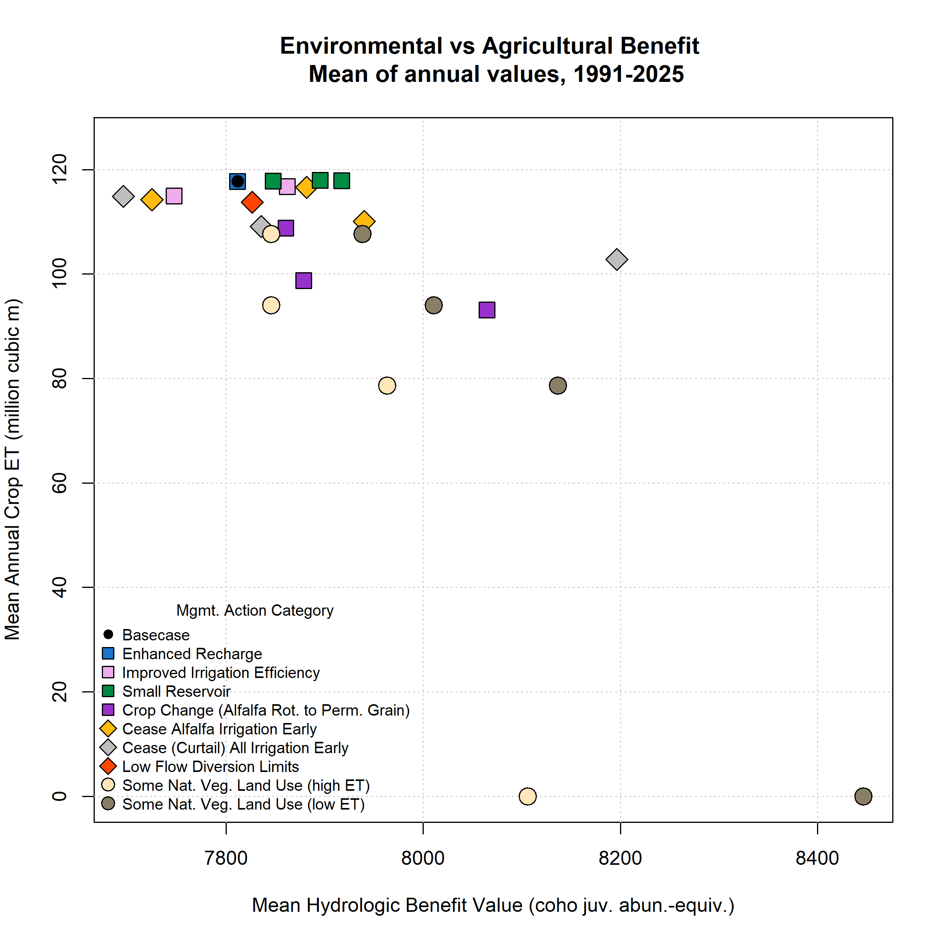
Figure 3: Environmental and agricultural objective function performance (in terms of Hydrologic Benefit, or HB, value; and crop ET volume) for basecase (black circle in upper left) and 25 management scenarios. Symbol x and y coordinates are the average of 35 annual HB and ET values for each scenario over the full model period (water years 1991-2025); for exampe time series of annual values, see previous figure.
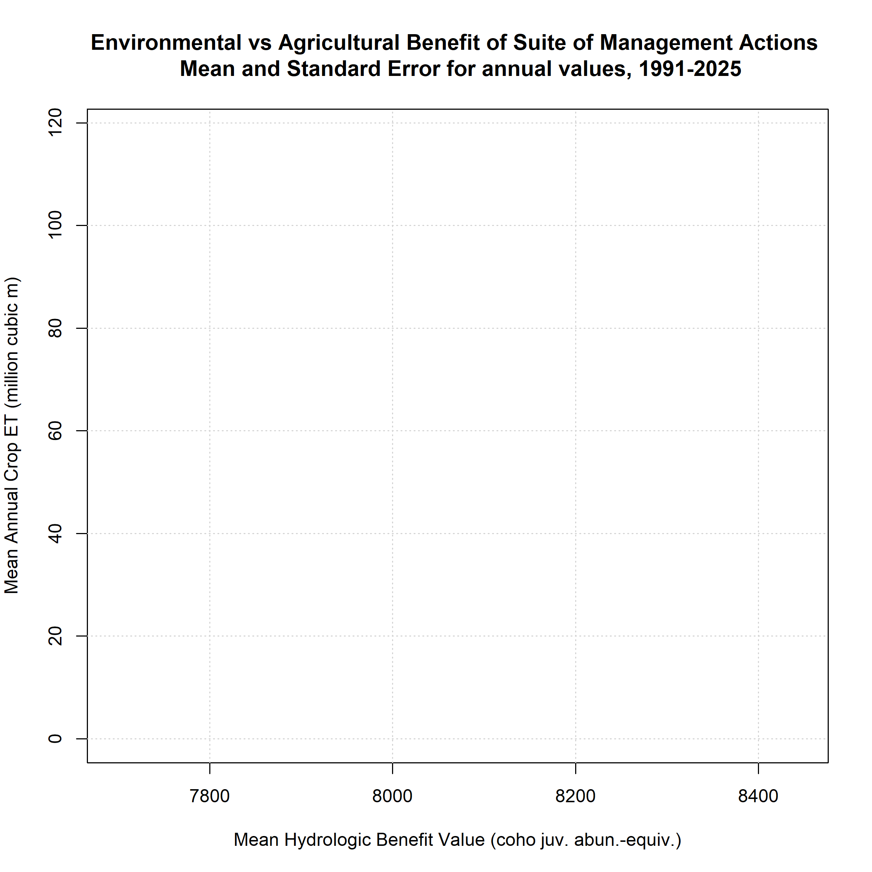
Figure 4: Scenario trade-off efficiencies, or average Hydrologic Benefit value (a proxy for environmental benefit) gained per crop ET value lost (a proxy for farmer cost) (normalized to average basecase HB and ET values, respectively), in all 35 years. Some scenarios are excluded if they have no or negative ET loss, producing infinite or negative efficiency values.

4 Three objectives and Pareto-optimal set
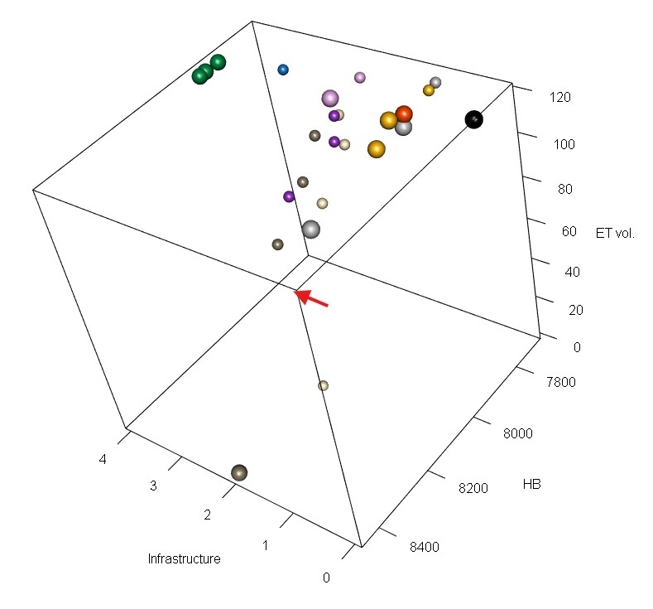
Figure 5: A three-dimensional scatter plot of the objective function values for basecase and 24 management scenarios, averaged over 35 water years (1991-2025). Larger spheres are shown for the Pareto-optimal set of scenarios. Scenario colors correspond to legend in Supplement Figures 3 and 4. The corner corresponding to optimal values of all objective functions (the ‘best’ corner) is highlighted with a red arrow.

5 Scenario Results Table
Table 2: Scenario attributes for 25 scenarios. Values in the Mean Hydrologic Benefit (HB) and Mean ET columns are averages of 35 annual values for each scenario. Efficiency not calculated for scenarios with no average ET loss.
Scenario ID | Category | Feas. | Mean HB / 1000 | Mean ET | Pareto | Efficiency
basecase | basecase | 0 | 7.81 | 117.76 | Yes | --
alf_curtail_07.15 | AlfIrr | 1 | 7.94 | 110.09 | Yes | 0.25
alf_curtail_07.31 | AlfIrr | 1 | 7.72 | 114.26 | -- | --
alf_curtail_08.15 | AlfIrr | 1 | 7.88 | 116.61 | Yes | 0.92
curtail_all_07.15 | Curtail | 1 | 8.20 | 102.83 | Yes | 0.39
curtail_all_07.31 | Curtail | 1 | 7.84 | 109.13 | Yes | 0.04
curtail_all_08.15 | Curtail | 1 | 7.70 | 114.91 | -- | --
eflows25_div_lims | FlowLims | 1 | 7.83 | 113.75 | Yes | 0.05
grain_12k | CropCh | 2 | 7.88 | 98.75 | -- | 0.05
grain_14k | CropCh | 2 | 8.06 | 93.16 | -- | 0.15
grain_6k | CropCh | 2 | 7.86 | 108.81 | -- | 0.08
irr_eff_0.1 | IrrEff | 2 | 7.86 | 116.74 | Yes | 0.74
irr_eff_0.2 | IrrEff | 2 | 7.75 | 114.98 | -- | --
maxMAR_fields2024 | EnhRch | 3 | 7.81 | 117.75 | -- | --
natveg_high_12k | NatVegH | 2 | 7.96 | 78.66 | -- | 0.06
natveg_high_4k | NatVegH | 2 | 7.85 | 107.70 | -- | 0.05
natveg_high_8k | NatVegH | 2 | 7.85 | 94.02 | -- | 0.02
natveg_high_all | NatVegH | 2 | 8.11 | 0.00 | -- | 0.04
natveg_low_12k | NatVegL | 2 | 8.14 | 78.66 | -- | 0.13
natveg_low_4k | NatVegL | 2 | 7.94 | 107.70 | -- | 0.19
natveg_low_8k | NatVegL | 2 | 8.01 | 94.02 | -- | 0.13
natveg_low_all | NatVegL | 2 | 8.45 | 0.00 | Yes | 0.08
reservoir_etna | Res | 4 | 7.92 | 117.87 | Yes | --
reservoir_french | Res | 4 | 7.85 | 117.84 | Yes | --
reservoir_shackleford | Res | 4 | 7.90 | 117.98 | Yes | --

6 Functional Flow Metrics
Annual values of the functional flow metrics highlighted in this Hydrologic Benefit function are tabulated below. The basecase and alfalfa irrigation scenarios are used as examples; for a graph of each scenario’s impact on simulated Fort Jones daily average flow, see Supplement E, Figure 2.

Table 3: For functional flow f1_FA_Dif_num: Annual functional flow values, for example scenarios, based on simulated Fort Jones daily average flow, which influence Hydrologic Benefit Function results.
brood_year | basecase | alf_curtail_08.15 | alf_curtail_07.31 | alf_curtail_07.15
1991
1992 | 72 | 69 | 89 | 69
1993 | 65 | 129 | 137 | 129
1994 | 141 | 134 | 124 | 121
1995 | 0 | 0 | 0 | 0
1996 | 1,986 | 1,984 | 299 | 293
1997 | 996 | 1,020 | 1,030 | 1,068
1998 | 106 | 105 | 104 | 96
1999 | 988 | 989 | 1,024 | 1,025
2000 | 197 | 195 | 195 | 201
2001 | 0 | 0 | 0 | 0
2002 | 37 | 39 | 173 | 111
2003 | 0 | 0 | 53 | 44
2004 | 45 | 465 | 447 | 438
2005 | 1,138 | 1,155 | 25 | 38
2006 | 59 | 59 | 57 | 52
2007 | 191 | 192 | 192 | 187
2008 | 35 | 75 | 203 | 234
2009 | 112 | 121 | 121 | 72
2010 | 39 | 58 | 42 | 33
2011 | 260 | 218 | 272 | 313
2012 | 0 | 39 | 7 | 6
2013 | 101 | 99 | 102 | 92
2014 | 0 | 0 | 0 | 0
2015 | 96 | 97 | 164 | 197
2016 | 177 | 218 | 221 | 230
2017 | 148 | 174 | 181 | 166
2018 | 59 | 59 | 52 | 67
2019 | 0 | 0 | 0 | 0
2020 | 122 | 120 | 119 | 119
2021 | 0 | 0 | 0 | 0
2022 | 42 | 42 | 110 | 158
2023 | 0 | 0 | 0 | 0
2024 | 47 | 47 | 46 | 18
2025 | 590 | 599 | 592 | 598

Table 4: For functional flow s1_SP_ROC: Annual functional flow values, for example scenarios, based on simulated Fort Jones daily average flow, which influence Hydrologic Benefit Function results.
brood_year | basecase | alf_curtail_08.15 | alf_curtail_07.31 | alf_curtail_07.15
1991 | 0.046 | 0.046 | 0.046 | 0.044
1992 | 0.048 | 0.049 | 0.048 | 0.048
1993 | 0.054 | 0.054 | 0.054 | 0.042
1994 | 0.056 | 0.060 | 0.060 | 0.060
1995 | 0.051 | 0.041 | 0.045 | 0.041
1996 | 0.060 | 0.060 | 0.059 | 0.045
1997 | 0.026 | 0.026 | 0.026 | 0.026
1998 | 0.052 | 0.036 | 0.038 | 0.034
1999 | 0.062 | 0.062 | 0.062 | 0.040
2000 | 0.049 | 0.048 | 0.045 | 0.036
2001 | 0.083 | 0.082 | 0.081 | 0.081
2002 | 0.050 | 0.050 | 0.050 | 0.046
2003 | 0.053 | 0.052 | 0.053 | 0.038
2004 | 0.046 | 0.046 | 0.046 | 0.044
2005 | 0.053 | 0.052 | 0.053 | 0.039
2006 | 0.041 | 0.041 | 0.041 | 0.041
2007 | 0.056 | 0.056 | 0.055 | 0.056
2008 | 0.067 | 0.068 | 0.068 | 0.041
2009 | 0.059 | 0.059 | 0.058 | 0.051
2010 | 0.059 | 0.048 | 0.050 | 0.038
2011 | 0.048 | 0.038 | 0.049 | 0.039
2012 | 0.059 | 0.058 | 0.058 | 0.040
2013 | 0.058 | 0.058 | 0.055 | 0.055
2014 | 0.042 | 0.041 | 0.040 | 0.040
2015 | 0.036 | 0.036 | 0.037 | 0.032
2016 | 0.057 | 0.057 | 0.057 | 0.042
2017 | 0.052 | 0.054 | 0.053 | 0.049
2018 | 0.058 | 0.058 | 0.058 | 0.058
2019 | 0.057 | 0.058 | 0.056 | 0.040
2020 | 0.062 | 0.062 | 0.062 | 0.062
2021 | 0.071 | 0.072 | 0.071 | 0.071
2022 | 0.046 | 0.052 | 0.052 | 0.043
2023 | 0.065 | 0.066 | 0.066 | 0.046
2024 | 0.061 | 0.067 | 0.066 | 0.049
2025 | 0.053 | 0.052 | 0.052 | 0.036

Table 5: For functional flow f2_FA_Dif_num: Annual functional flow values, for example scenarios, based on simulated Fort Jones daily average flow, which influence Hydrologic Benefit Function results.
brood_year | basecase | alf_curtail_08.15 | alf_curtail_07.31 | alf_curtail_07.15
1991 | 72 | 69 | 89 | 69
1992 | 65 | 129 | 137 | 129
1993 | 141 | 134 | 124 | 121
1994 | 0 | 0 | 0 | 0
1995 | 1,986 | 1,984 | 299 | 293
1996 | 996 | 1,020 | 1,030 | 1,068
1997 | 106 | 105 | 104 | 96
1998 | 988 | 989 | 1,024 | 1,025
1999 | 197 | 195 | 195 | 201
2000 | 0 | 0 | 0 | 0
2001 | 37 | 39 | 173 | 111
2002 | 0 | 0 | 53 | 44
2003 | 45 | 465 | 447 | 438
2004 | 1,138 | 1,155 | 25 | 38
2005 | 59 | 59 | 57 | 52
2006 | 191 | 192 | 192 | 187
2007 | 35 | 75 | 203 | 234
2008 | 112 | 121 | 121 | 72
2009 | 39 | 58 | 42 | 33
2010 | 260 | 218 | 272 | 313
2011 | 0 | 39 | 7 | 6
2012 | 101 | 99 | 102 | 92
2013 | 0 | 0 | 0 | 0
2014 | 96 | 97 | 164 | 197
2015 | 177 | 218 | 221 | 230
2016 | 148 | 174 | 181 | 166
2017 | 59 | 59 | 52 | 67
2018 | 0 | 0 | 0 | 0
2019 | 122 | 120 | 119 | 119
2020 | 0 | 0 | 0 | 0
2021 | 42 | 42 | 110 | 158
2022 | 0 | 0 | 0 | 0
2023 | 47 | 47 | 46 | 18
2024 | 590 | 599 | 592 | 598
2025

Kouba, Claire, Leland Scantlebury, Jason Wiener, Sarah Yarnell, and Thomas Harter. 2025. “A Watershed-Specific Approach to Identify Key Functional Flow Metrics Supporting Salmon Reproduction.” Ecohydrology : Ecosystems, Land and Water Process Interactions, Ecohydrogeomorphology 18 (5): e70098. https://doi.org/10.1002/eco.70098.

